Ingeniería de software 2

Workshop No. 3 - Full Stack Implementation and Testing



Profesor:
Carlos Andres Sierra Virguez

Integrantes:

Alejandro Argüello Muñoz
Juan Sebastián Umaña Camacho
Juan Luis Vergara Novoa
Tomás Felipe Garzón Gómez
Tomás Sebastián Vallejo Fonseca
Juan Diego Velasquez Pinzon

Facultad de Ingeniería
Departamento de Ingeniería de Sistemas e Industrial
Universidad Nacional de Colombia

Bogotá D.C

Database implementation
The application integrates three different databases, each serving a distinct purpose within the platform’s architecture: Clerk, Stream, and a custom PostgreSQL database managed with Prisma ORM. All external services (Clerk and Stream) are accessed exclusively via REST APIs, while the PostgreSQL database is accessed through both REST endpoints and the Prisma Client ORM.
Together, these databases support a scalable video conferencing and social networking platform with features such as real-time communication, friend management, role-based access control (RBAC), and strict audit logging.

Clerk Database
Clerk is responsible for authentication and identity management. We rely on Clerk’s Users table as the single source of truth for all user identities. Each user is identified by a Clerk User ID, which is referenced by Stream and the PostgreSQL database to maintain consistent cross-service identity mapping.

Stream Database
The stream tables that our application uses are:
- Call – Represents live or historical video calls.
- Recordings – Stores recordings associated with call sessions.
- Users – A representation of platform users within Stream, directly linked to Clerk’s Users table by using the Clerk User ID as the primary key.
All interactions with stream tables are performed through the Stream REST API, enabling low-latency communication features and event-driven updates.

PostgreSQL Database (Prisma ORM)
The core application data model resides in a PostgreSQL database managed through Prisma ORM.The schema follows Third Normal Form (3NF), ensuring a clean, scalable, and maintainable structure suitable for a distributed production environment. All primary keys are UUIDs to enhance security and support horizontal scaling. This database stores project-specific entities, including the friend connection system, RBAC data, and auditable records of user actions.

Bidirectional & Social Relationships
The system’s relational design allows for self-referential Many-to-Many relationships on the User entity. This structure is used to model social connections (friends, acquaintances, blocked users) in a scalable, database-normalized way.

Connection State Machine
A strict state machine governs the lifecycle of user-to-user relationships:
- PENDING – A request has been sent.
- ACCEPTED – Users are connected.
- BLOCKED – One user has restricted contact.
The state machine is enforced by:
- Enums restricting invalid states.
- Composite unique constraints preventing duplicate or conflicting relationships.
This guarantees consistency and predictability throughout friendship and connection workflows.

Sample data for testing

- Example table: FriendRequest
- Seeding command: npx prisma db seed
- Database inspection command: npx prisma studio

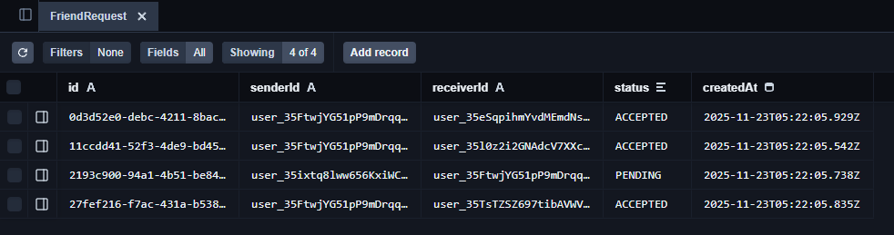
Figure 1. Running prisma studio with sample data seed

Database Diagram

    - Attached File Name: [DBmodel.pdf]

Backend services
Some examples of backend implementation:
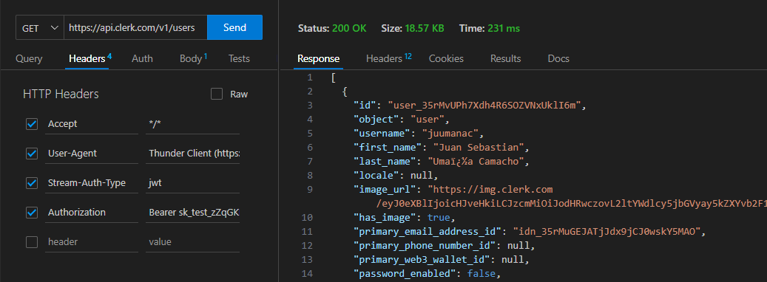
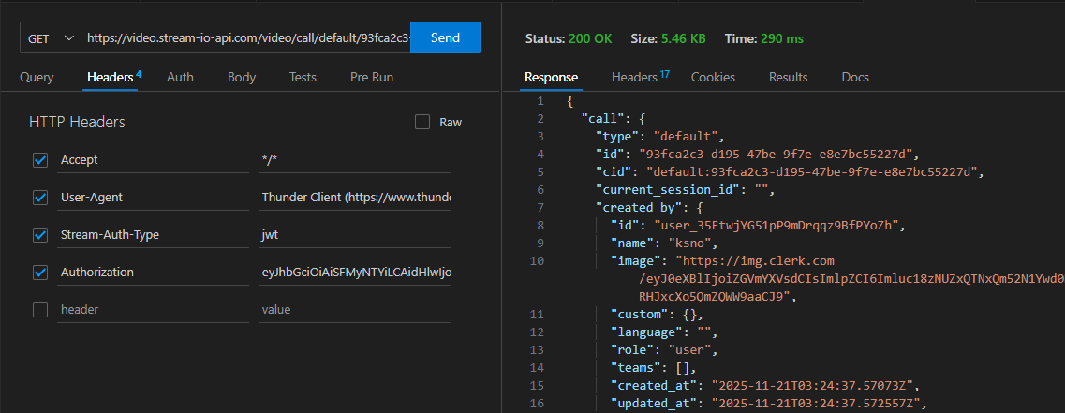
Figure 2. Get all clerk users
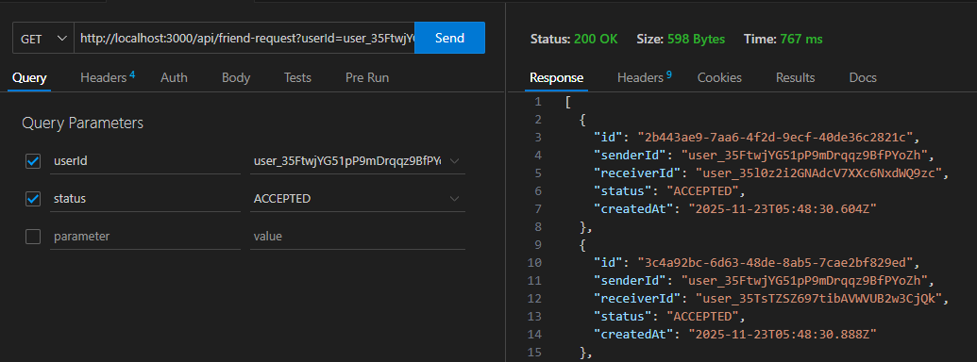
Figure 3. Get a stream call
Figure 4. Get an user friends

Web Frontend
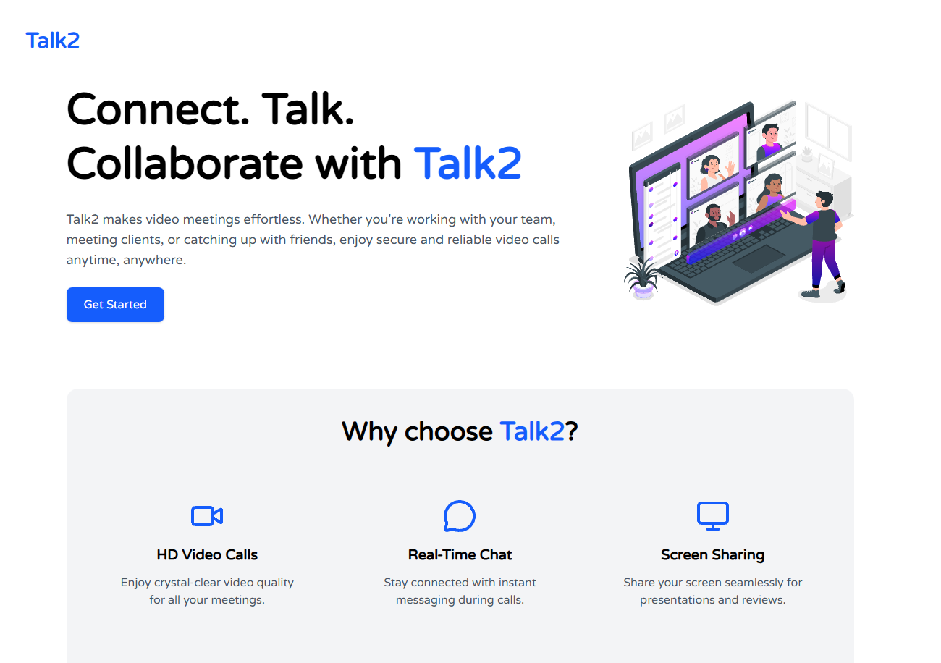
Figure 5. Landing Page
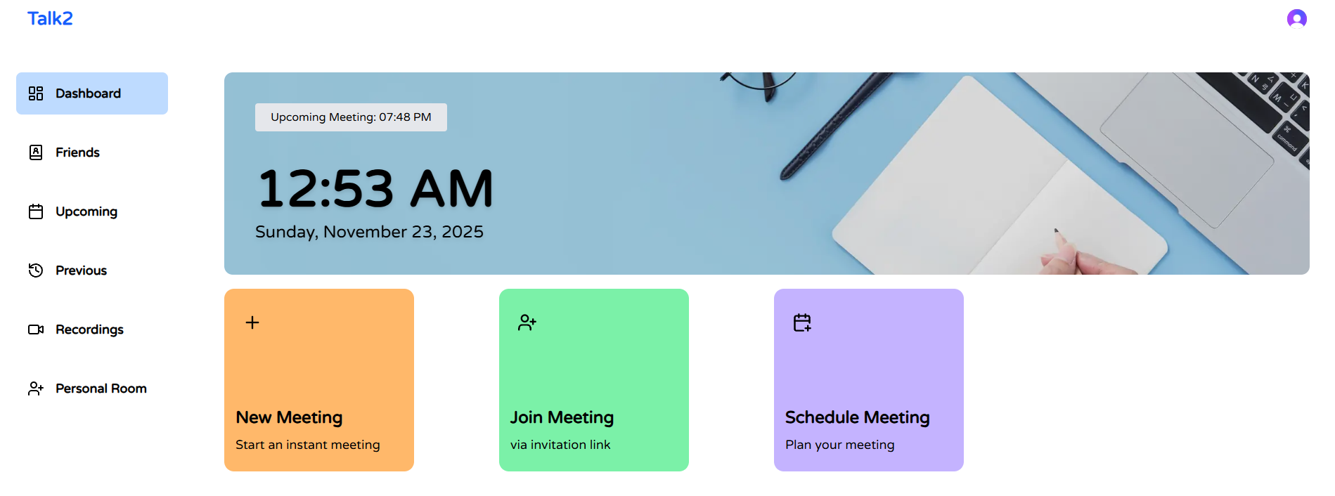
Figure 6. Dashboard
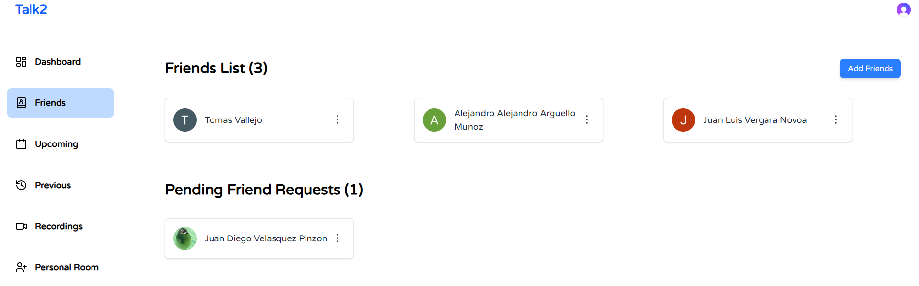
Figure 7. Friends tab

Unit Testing

The application includes a test suite implemented using Cypress, focusing on the complete CRUD lifecycle of the API’S. These tests validate backend correctness, input validation, state-machine transitions, and error handling. Before each test, the database is reset using cy.resetDB() to ensure deterministic and isolated execution.

- Testing library: Cypress
- Example test: FriendRequest Full Crud

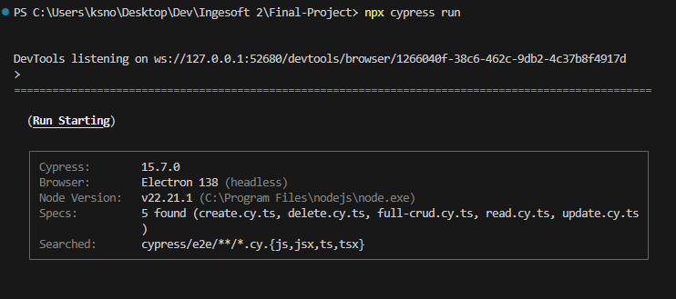
Figure 8. Unit test startup

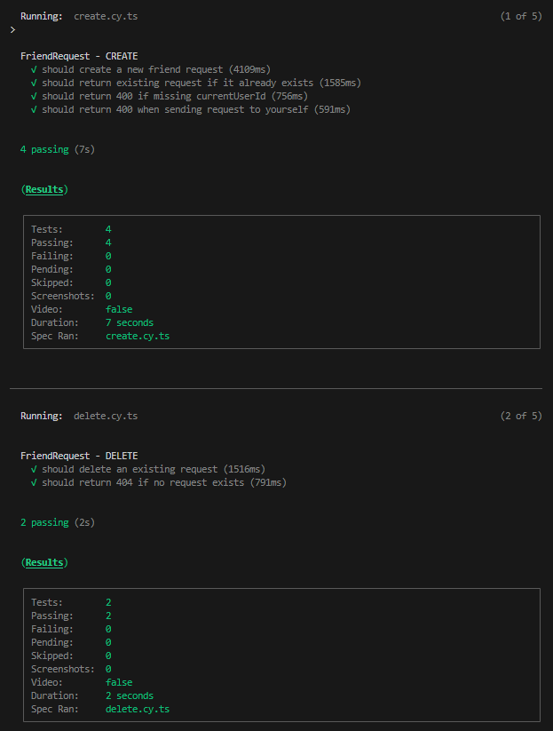
Figure 9. Create and delete unit test

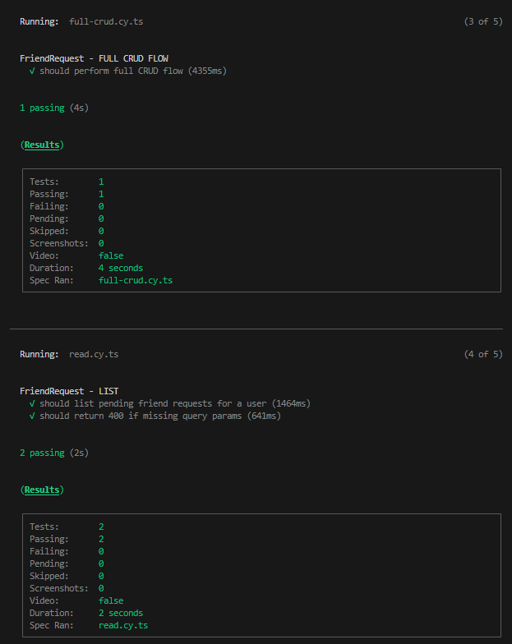
Figure 10. Full crud flow and get (list) unit test

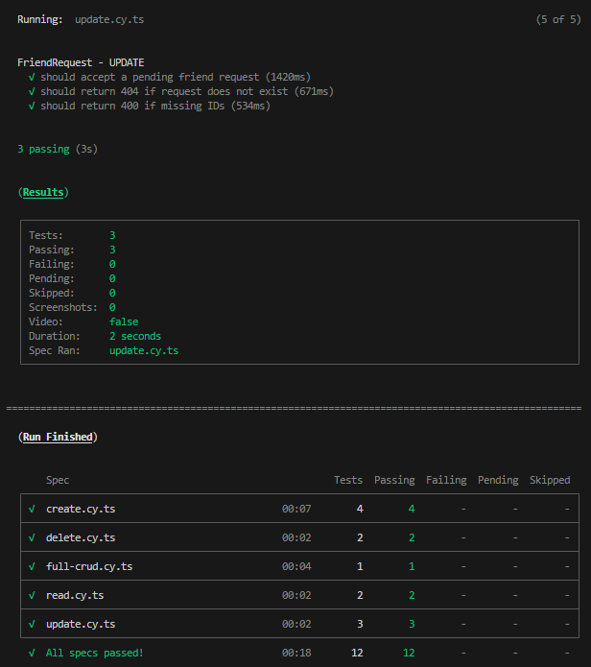
Figure 11. Update test and unit test summary

Integration Evidence
Some examples of backend-frontend integration in the app:
Backend Endpoint (Get call):
- GET https://video.stream-io-api.com/video/call/{type}/{id}

Frontend (Upcoming tab):

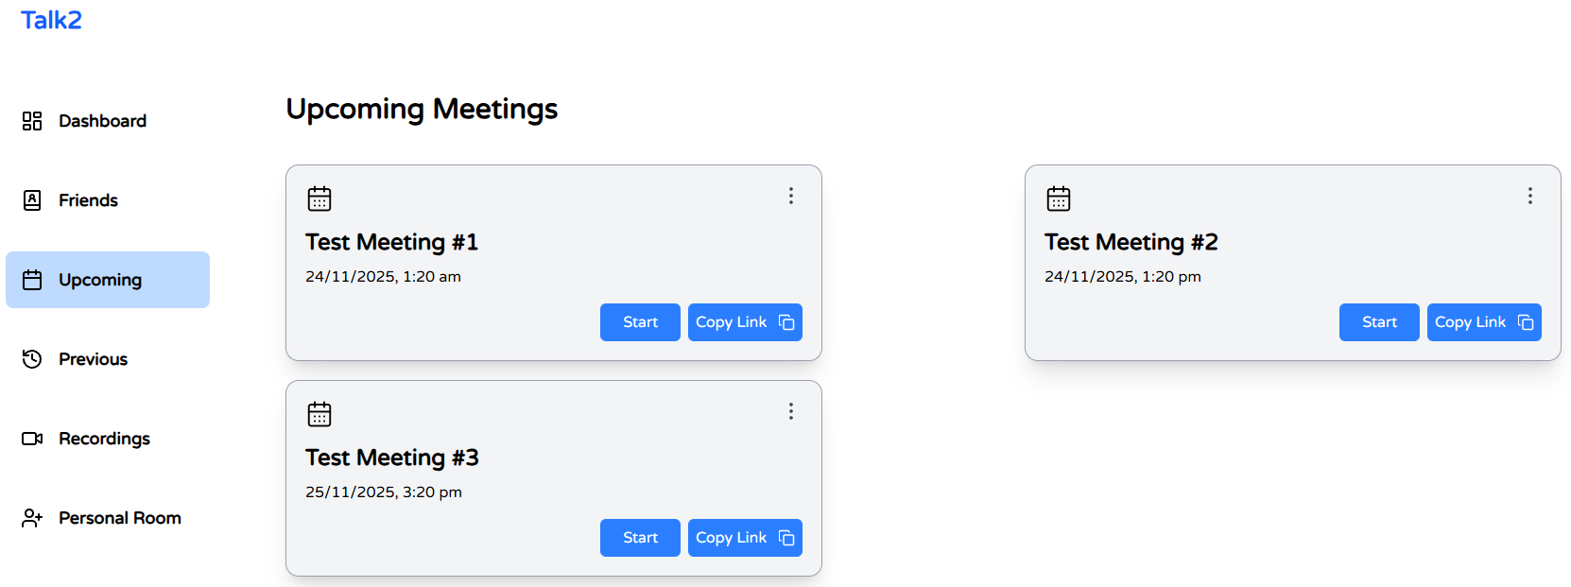

Backend Endpoint (Create call):
- POST https://video.stream-io-api.com/video/call/{type}/{id}

Frontend (Call Room):

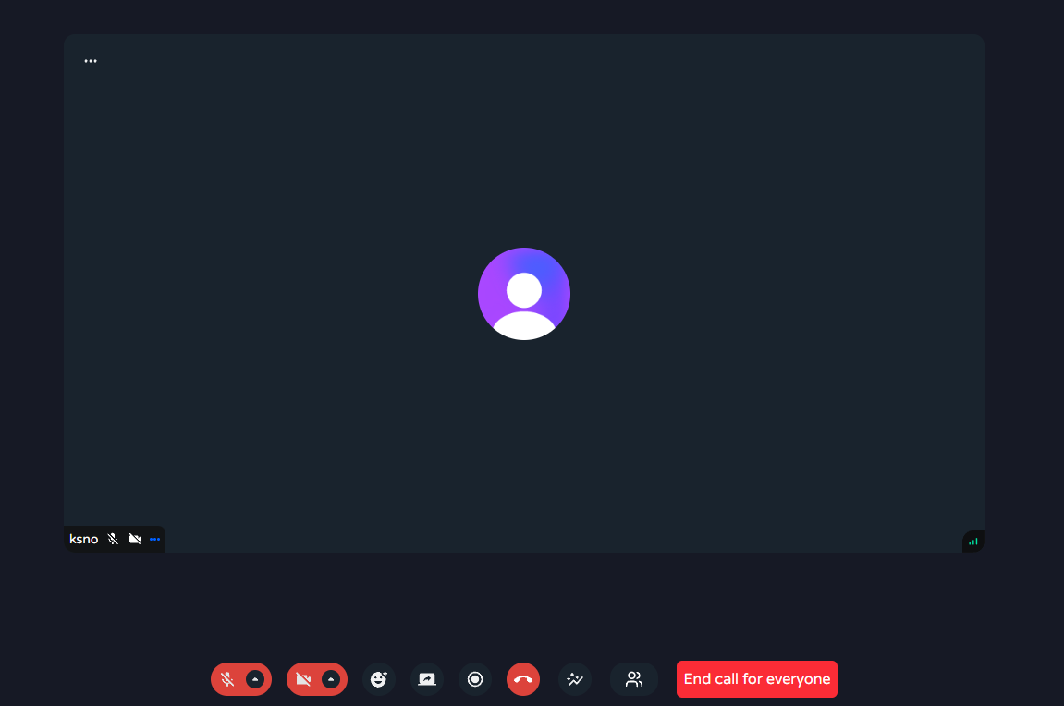
Backend Endpoint (GET users):
- GET https://api.clerk.com/v1/users

Frontend (Add friends modal):

